**MONGODB DAY 1**

For the following question write the corresponding MongoDB queries

1. Find all the information about each products

**Answer :**

db.products.find({})

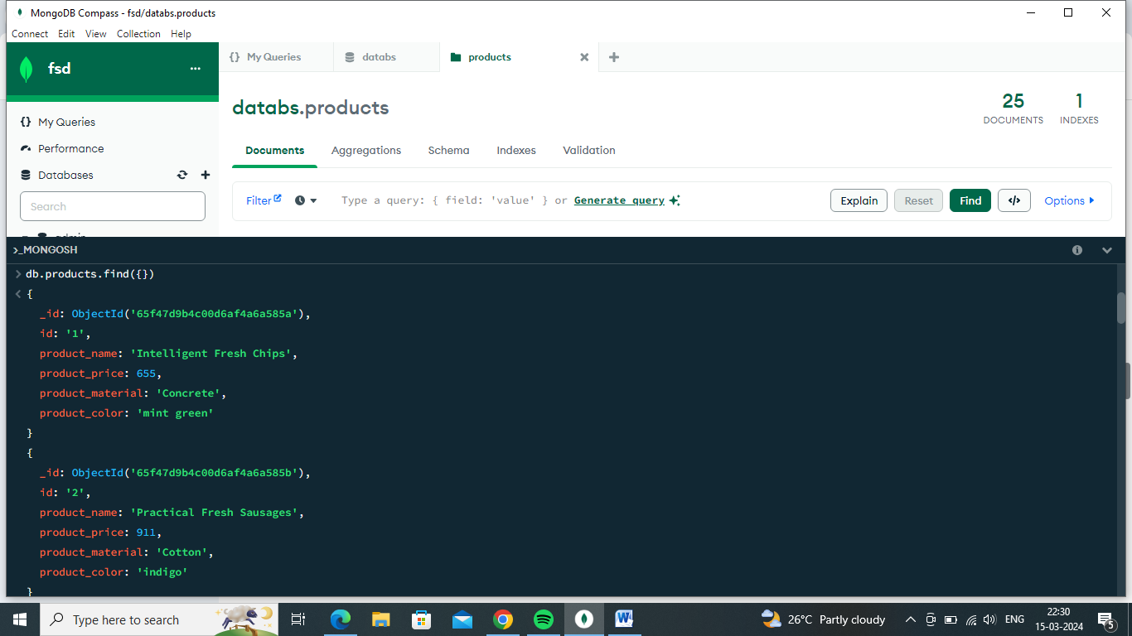

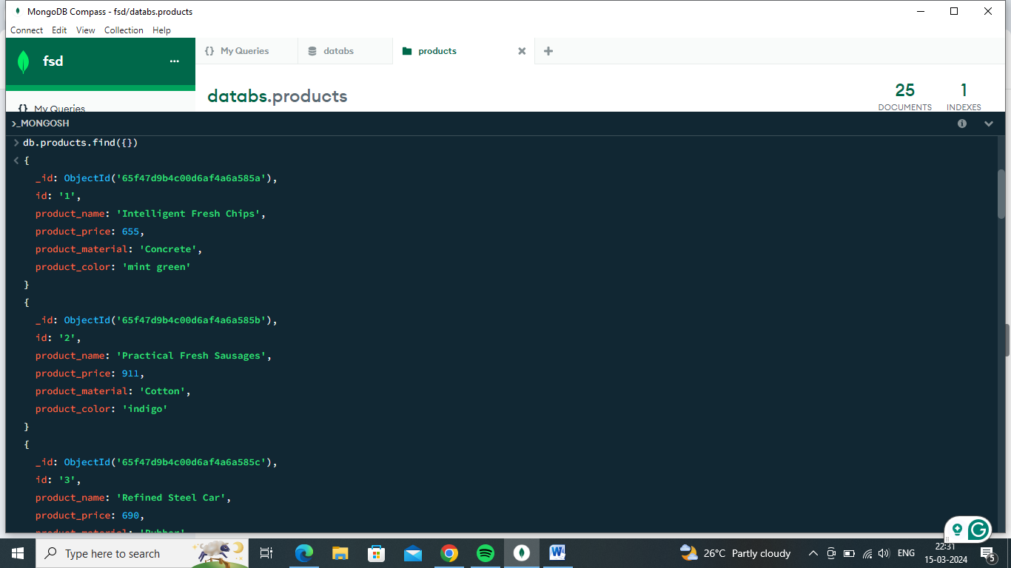

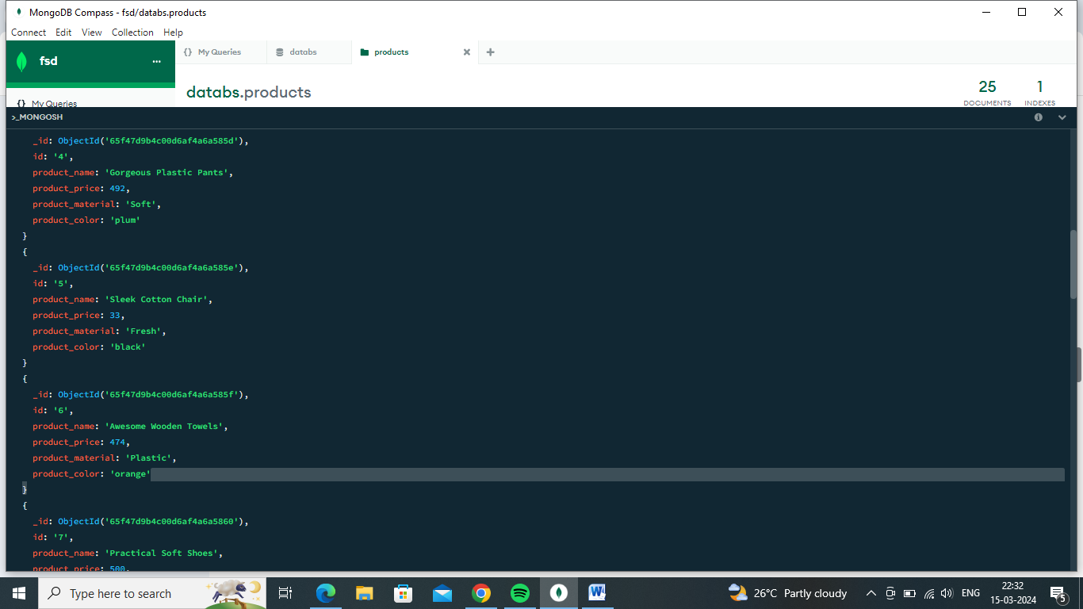

1. Find the product price which are between 400 to 800

**Answer :**

db.products.find({ product_price: { $gt: 400, $lt: 800 } })

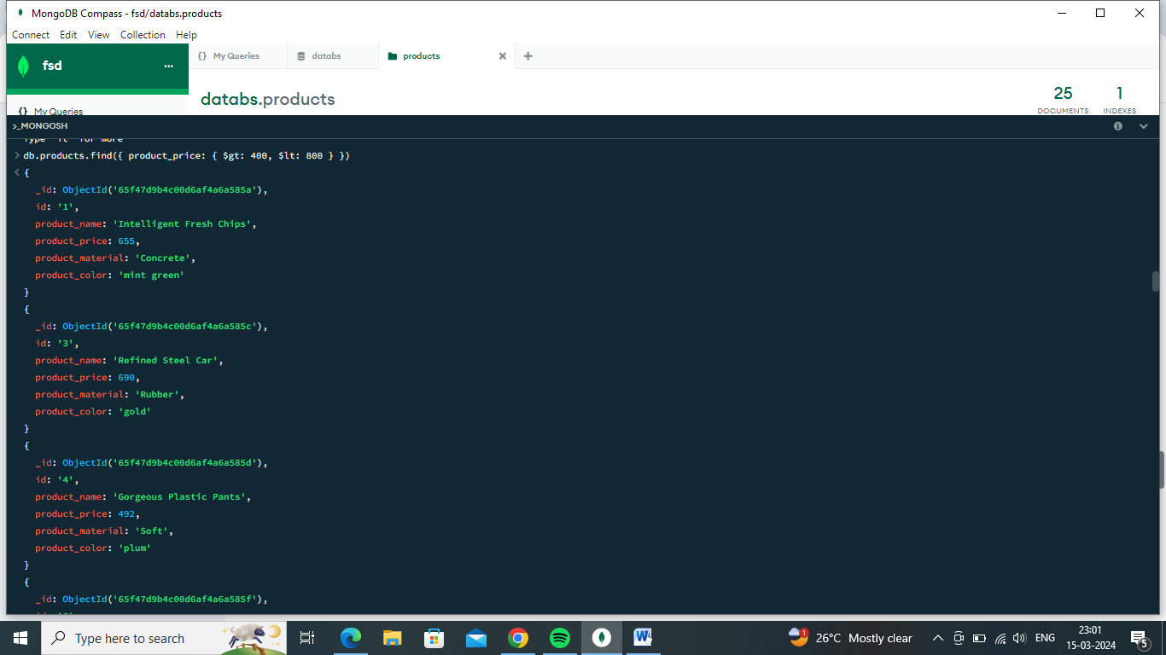

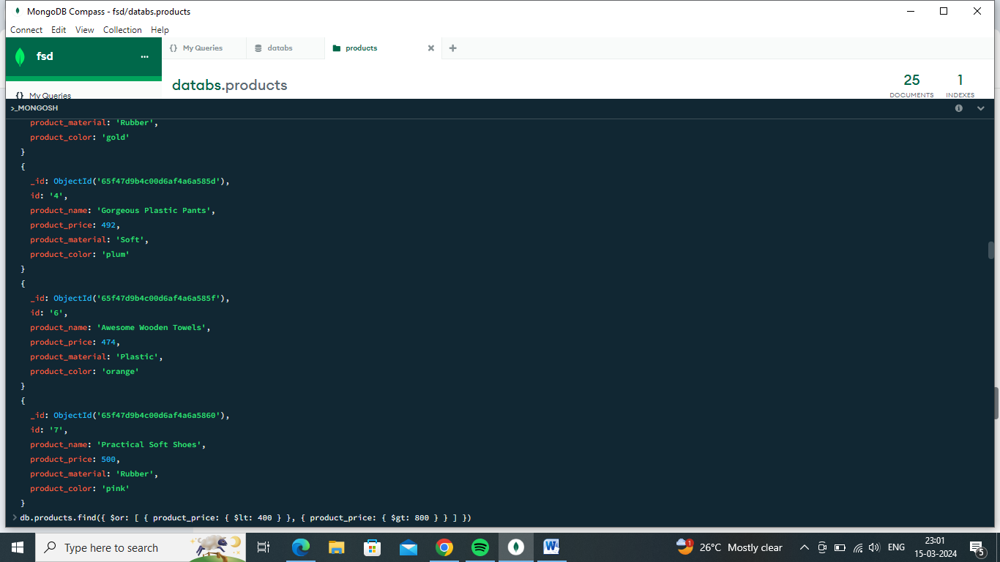

1. Find the product price which are not between 400 to 600

**Answer :**

db.products.find({ $or: [ { product_price: { $lt: 400 } }, { product_price: { $gt: 800 } } ] })

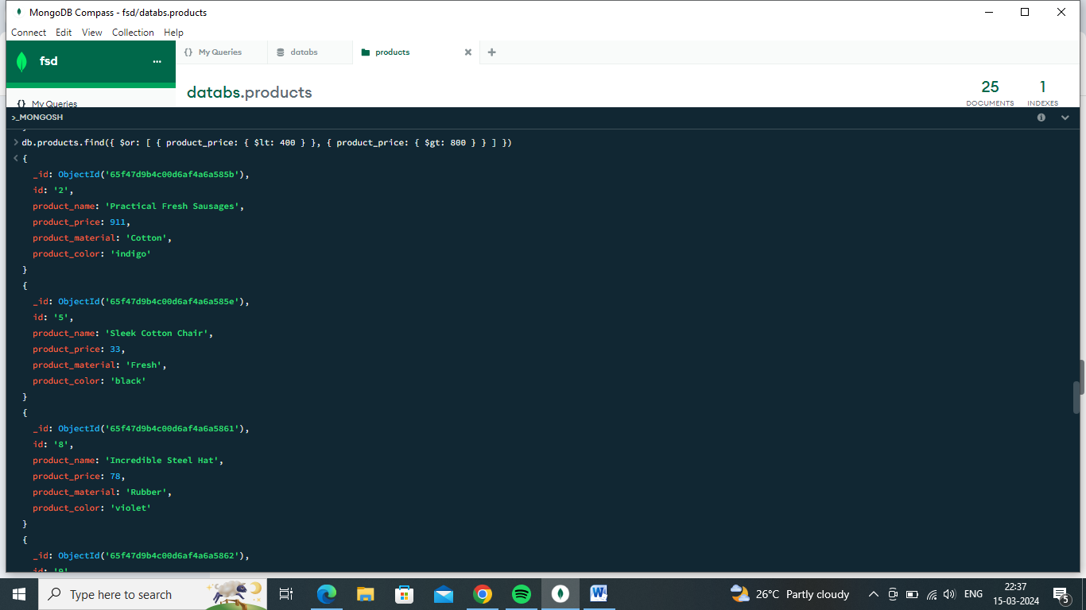

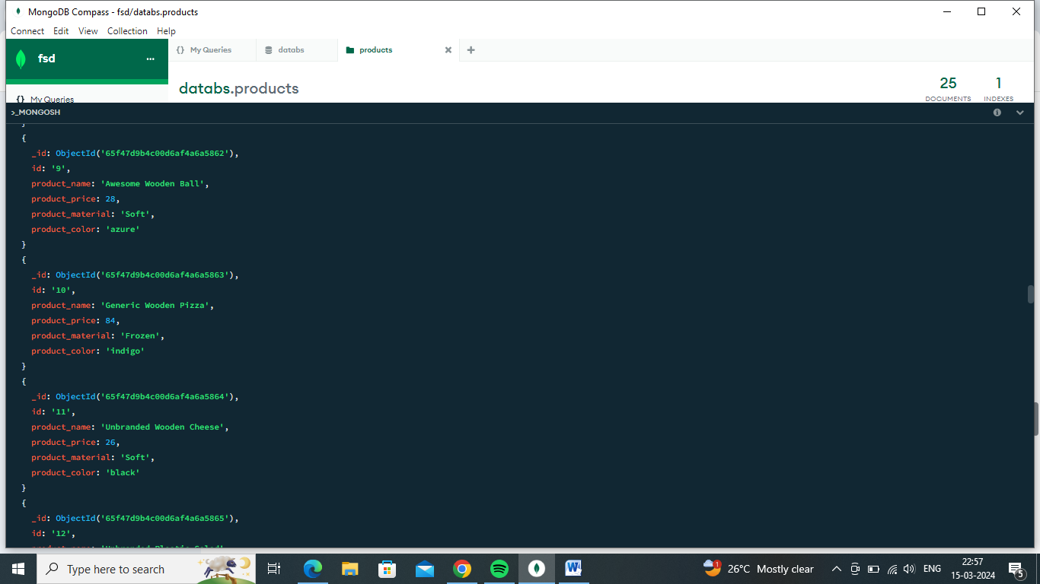

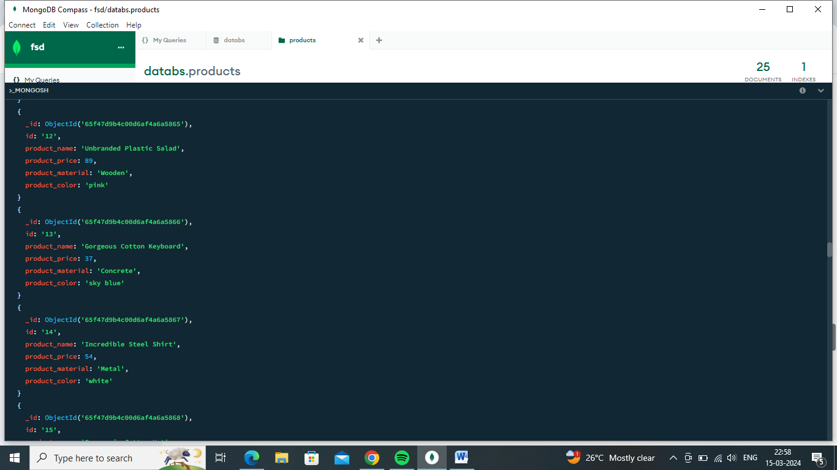

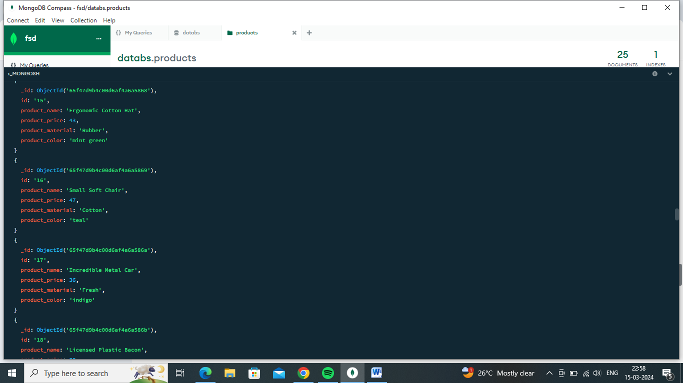

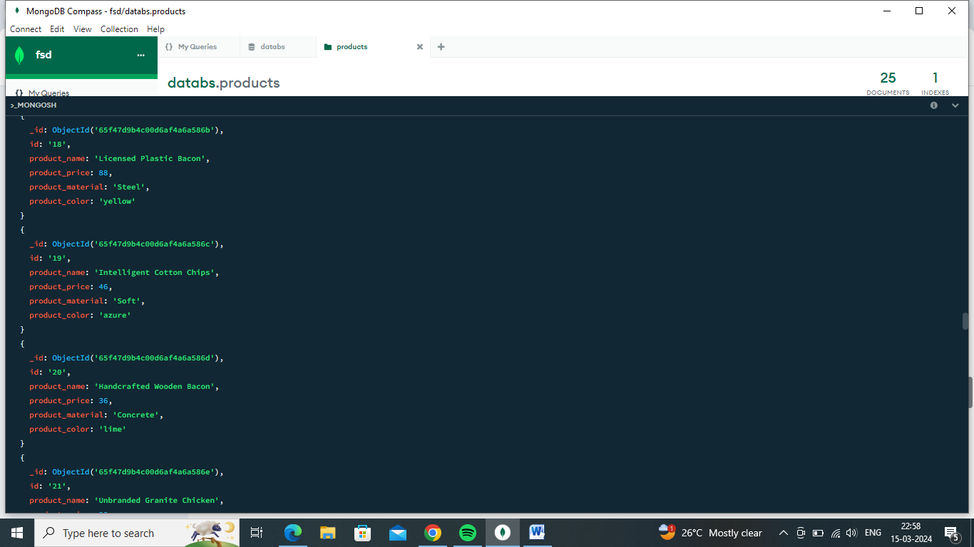

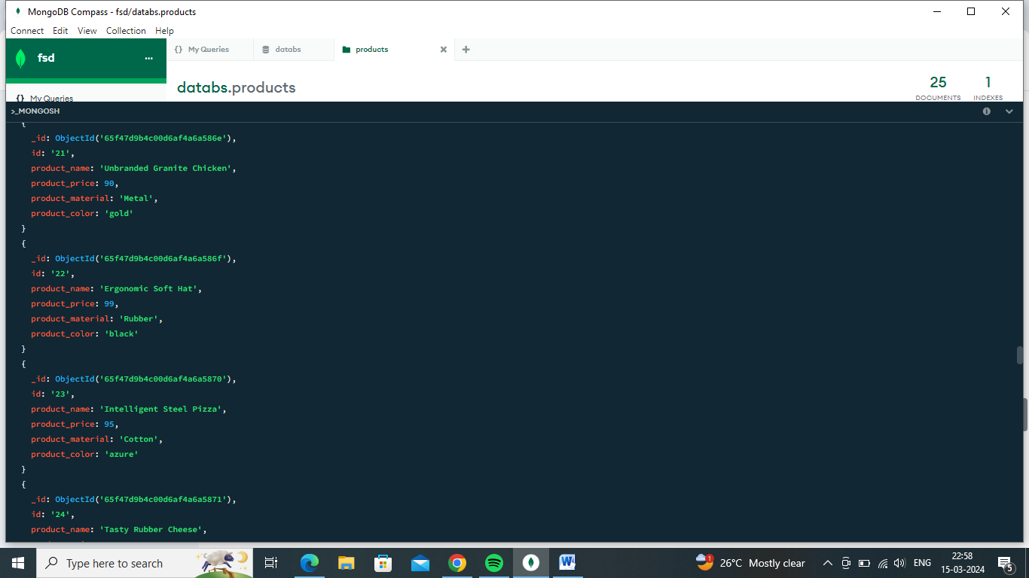

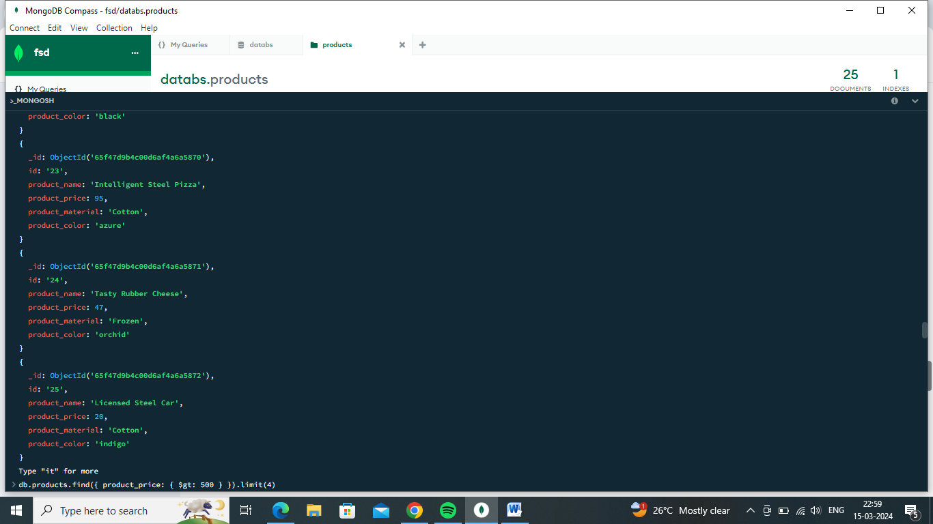

1. List the four product which are greater than 500 in price

**Answer:**

db.products.find({ product_price: { $gt: 500 } }).limit(4)

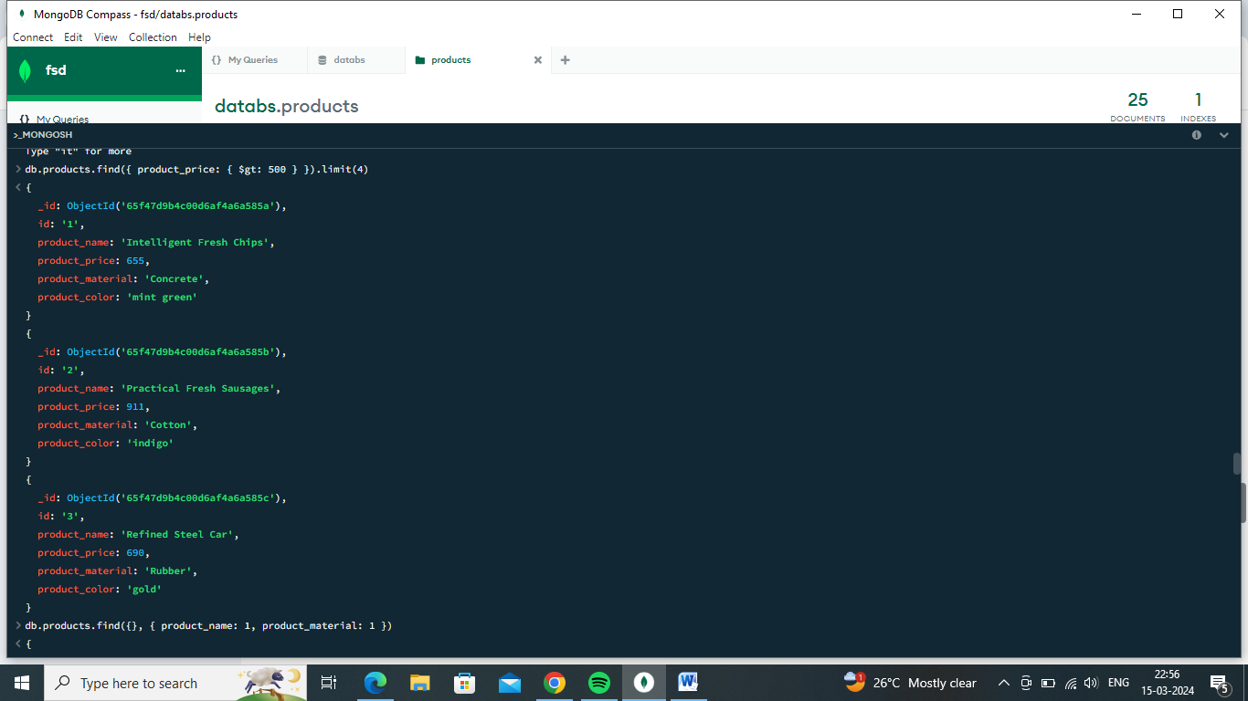

1. Find the product name and product material of each products

**Answer :**

db.products.find({}, { product_name: 1, product_material: 1 })

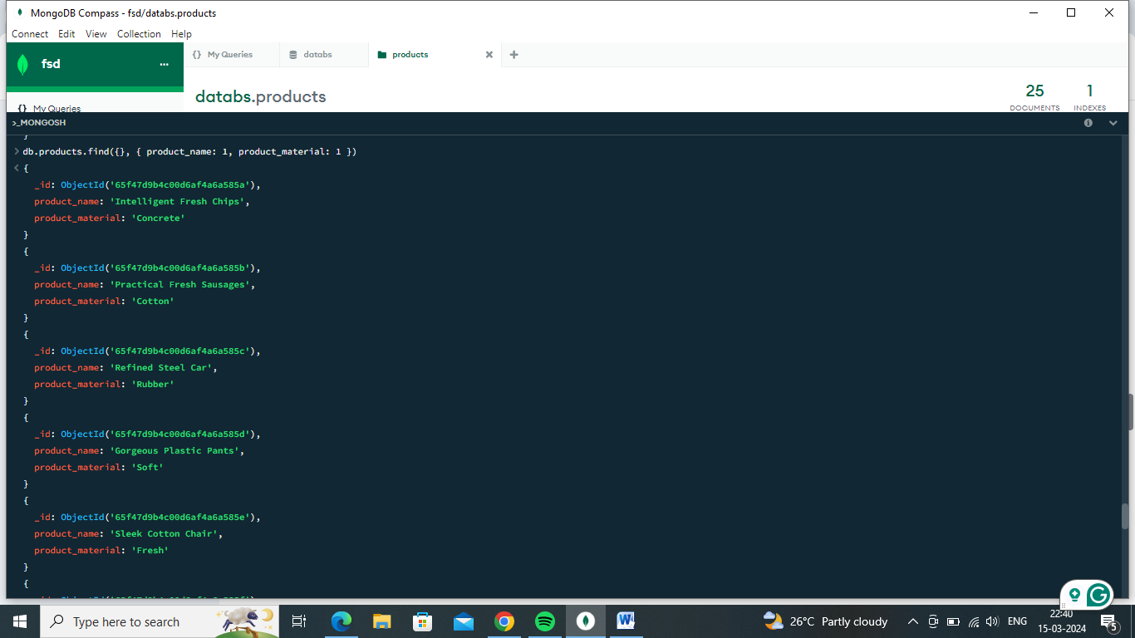

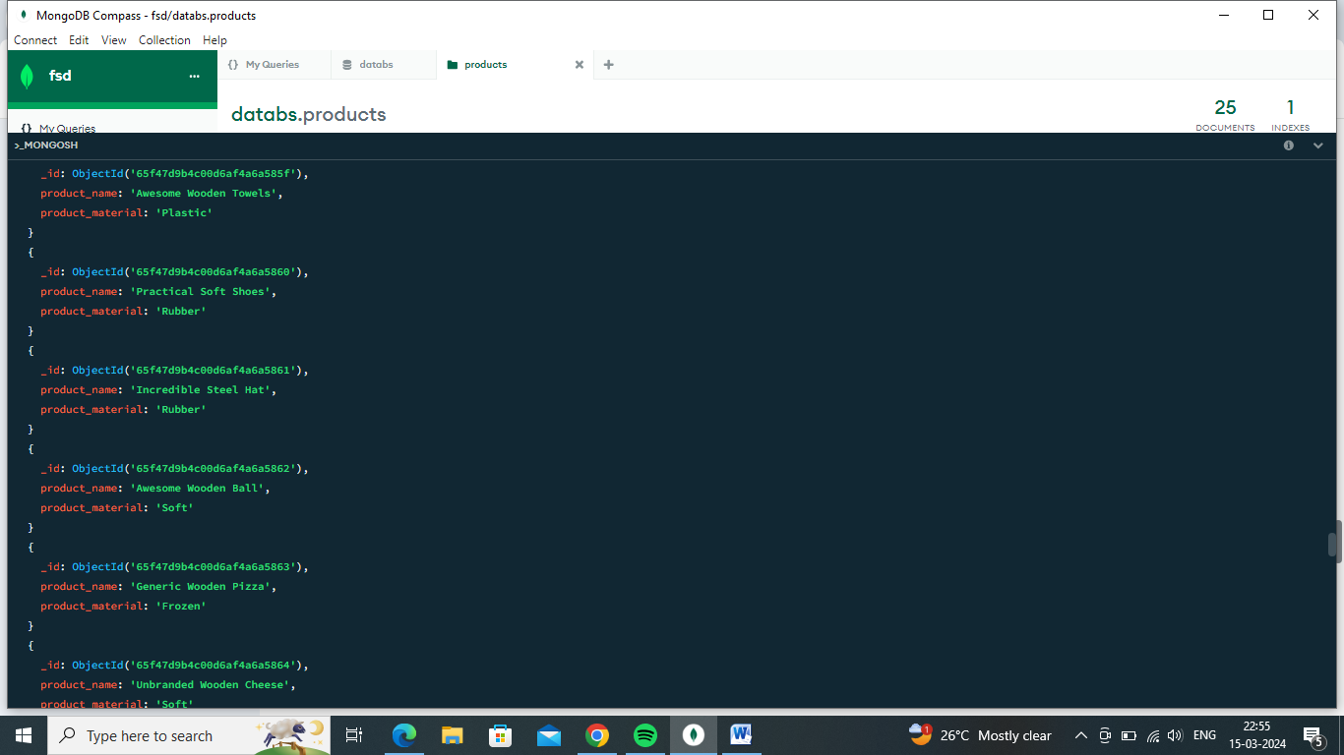

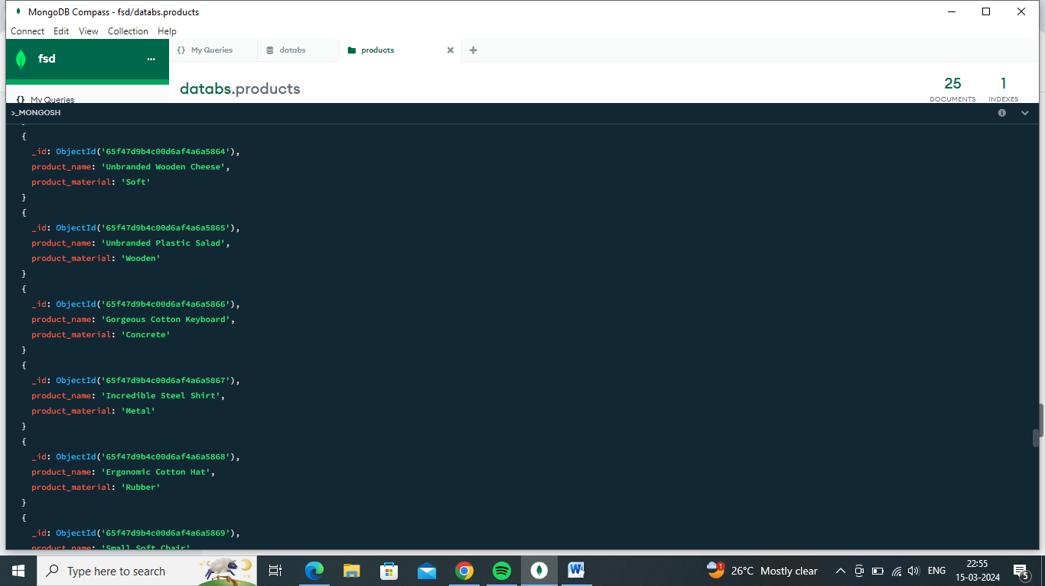

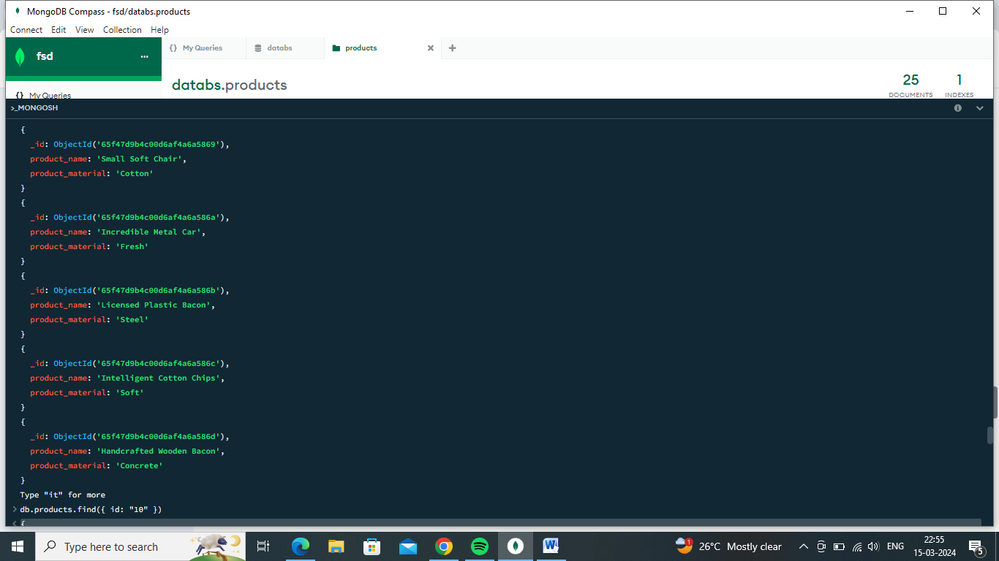

1. Find the product with a row id of 10

**Answer :**

db.products.find({ id: "10" })

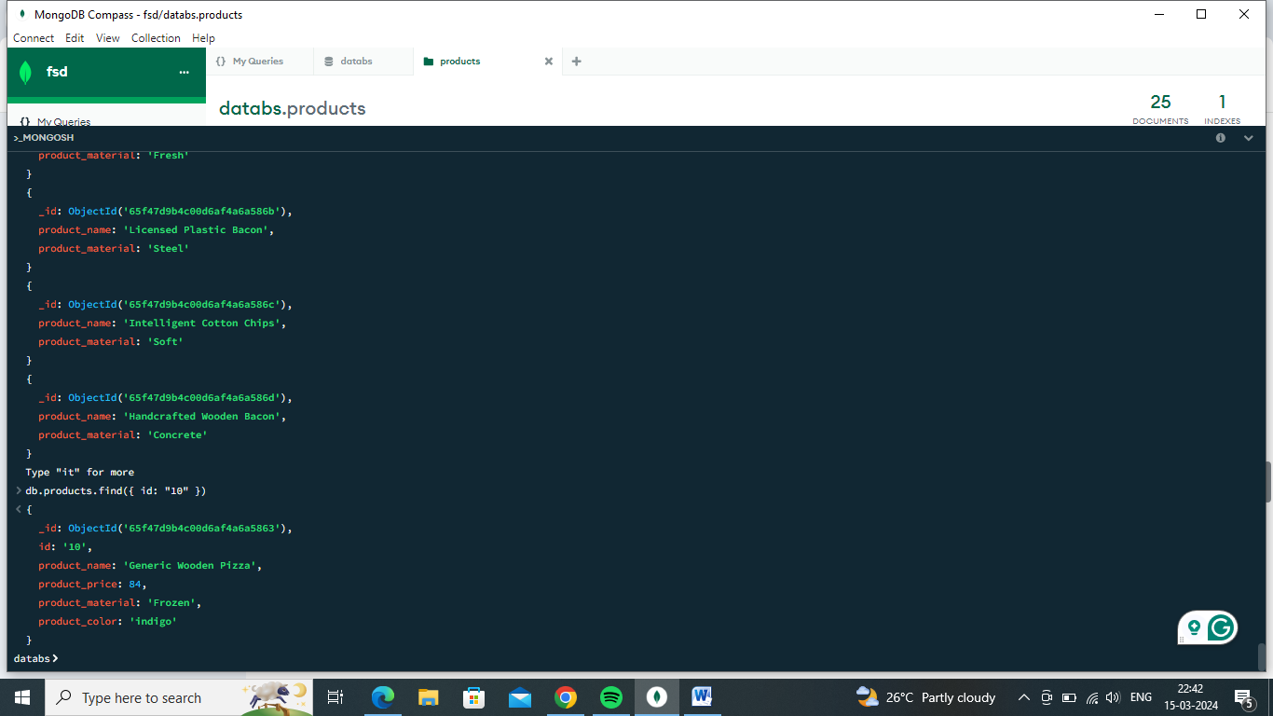

1. Find only the product name and product material

**Answer :**

db.products.find({}, { _id: 0, product_name: 1, product_material: 1 })

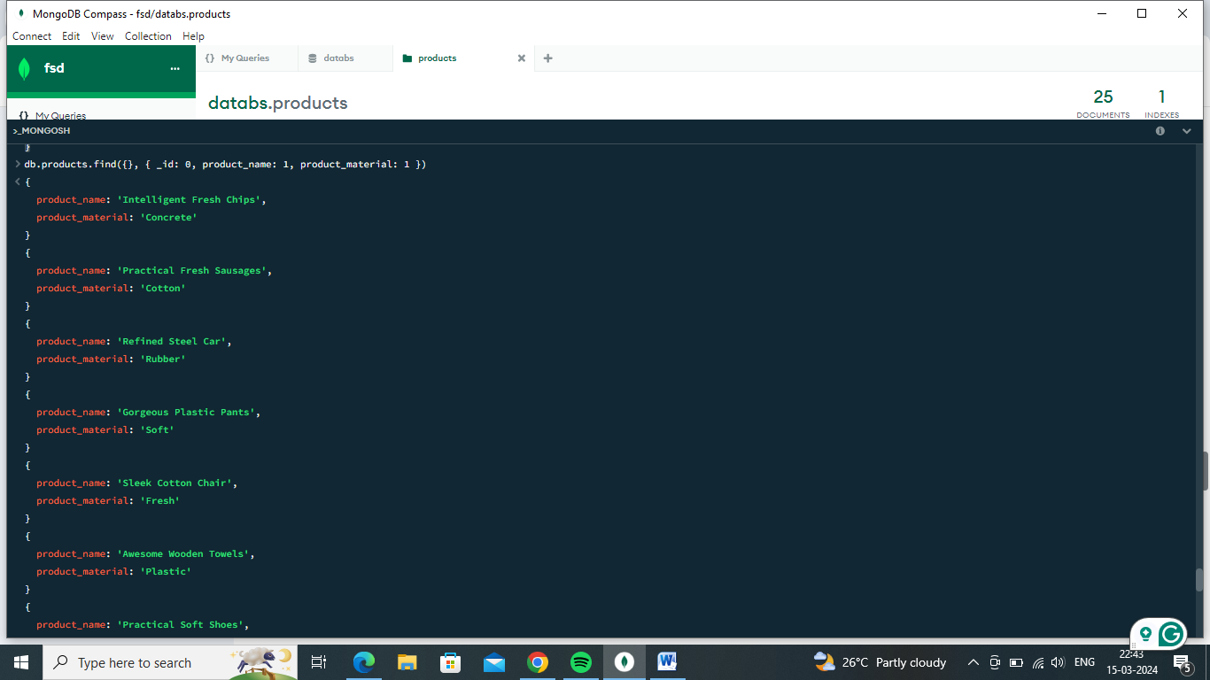

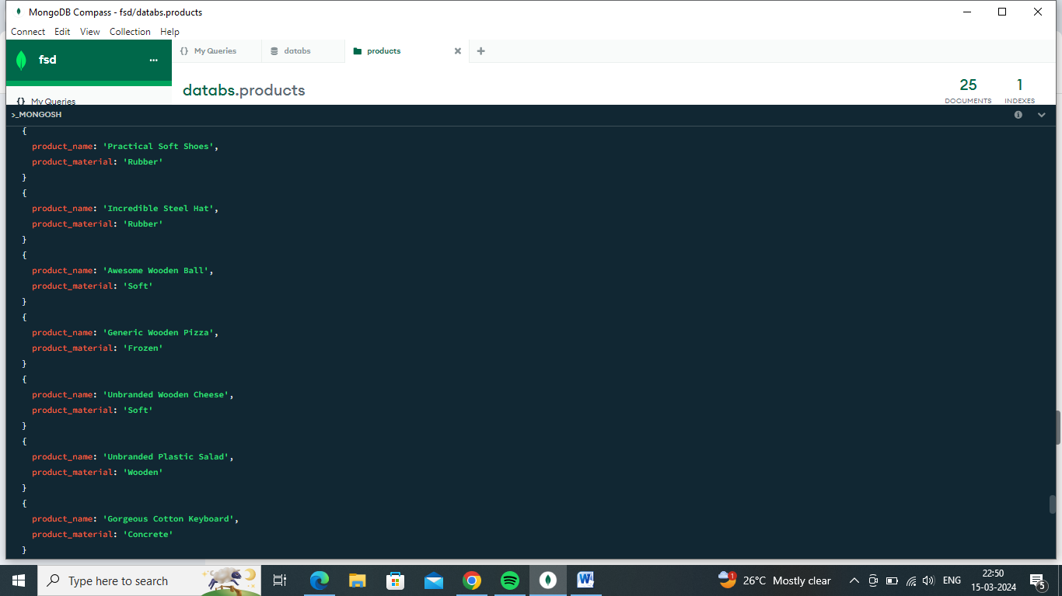

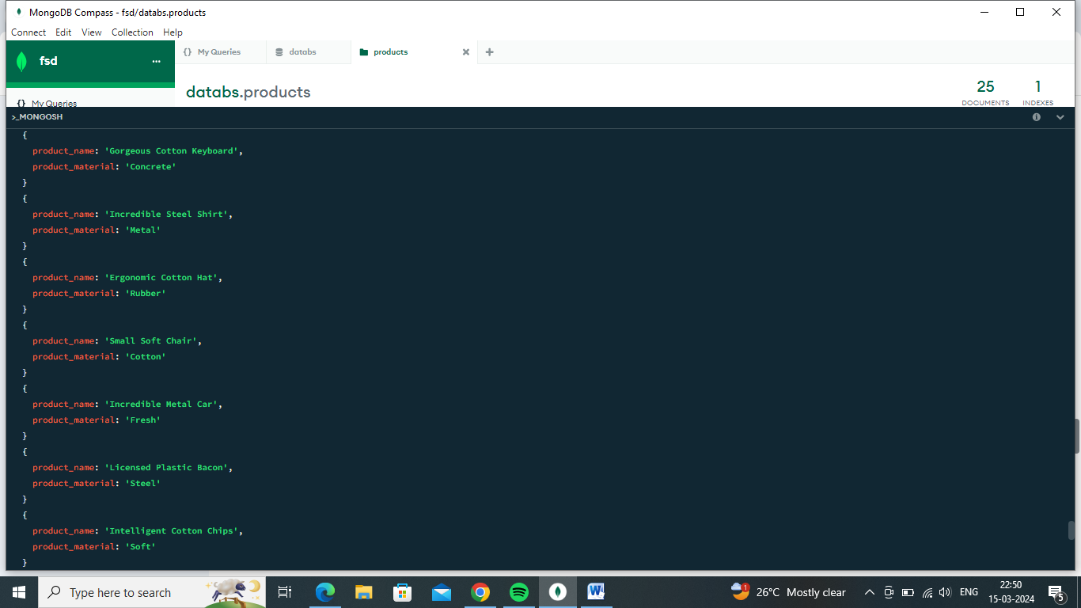

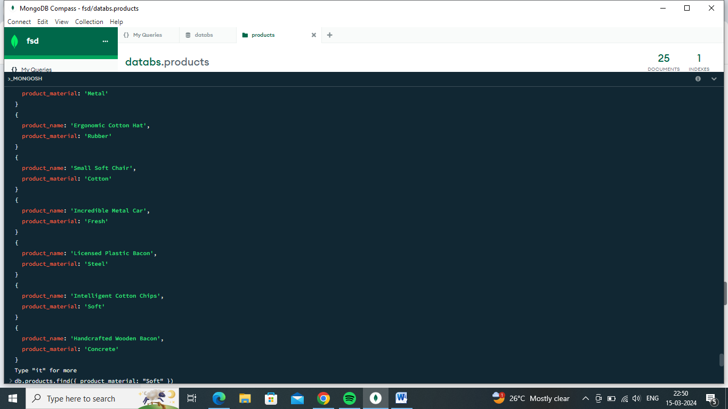

1. Find all products which contain the value of soft in product material

**Answer :**

db.products.find({ product_material: "Soft" })

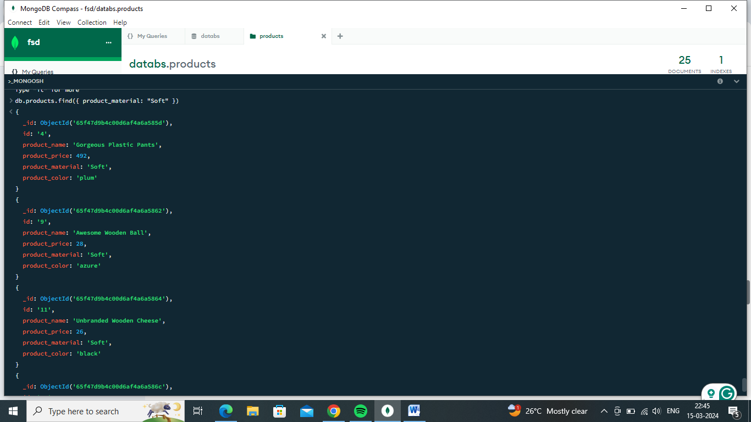

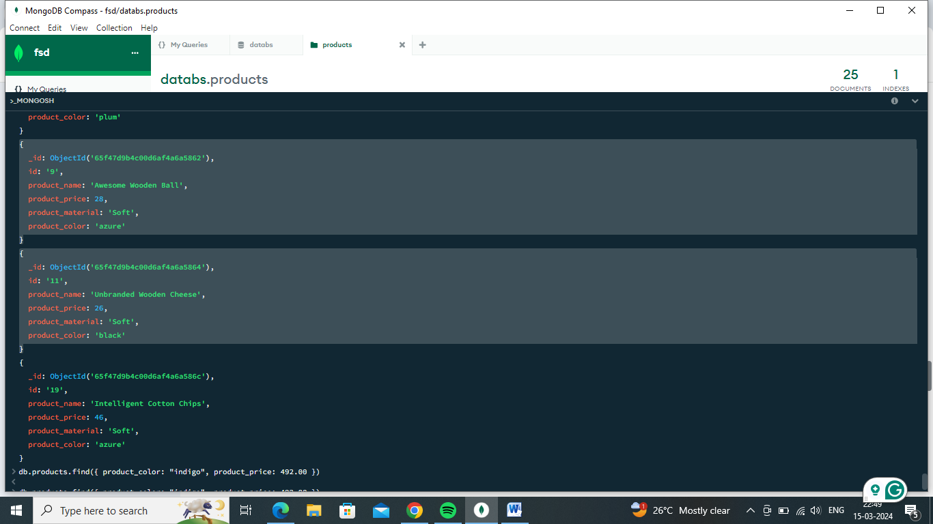

1. Find products which contain product color indigo  and product price 492.00

**Answer :**

db.products.find({ product_color: "indigo", product_price: 492.00 })

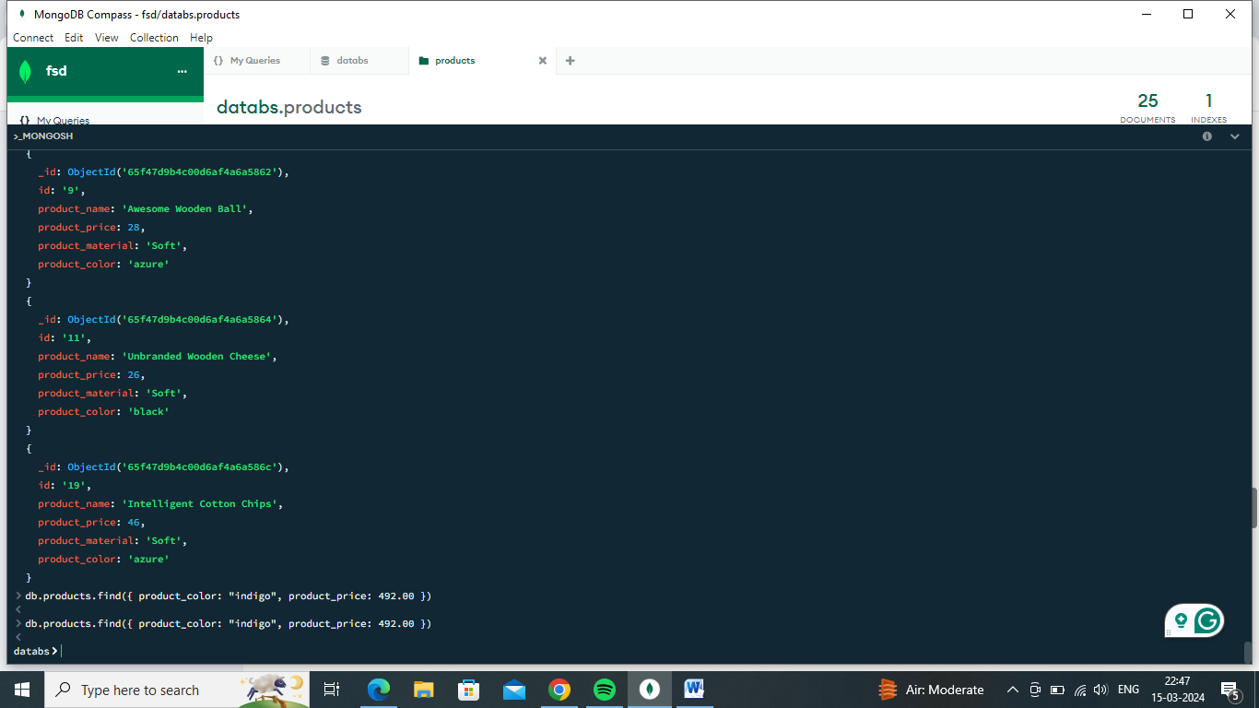

1. Delete the products which product price value are same

**Answer:**

db.products.deleteMany({ product_price: { $in: [<list_of_duplicate_prices>] } })